**Moon Walkers**

SELENE PROJECT

We chose to look for a possible solution against lunar dust; because these small dust articles are very harmful to the spaceship and the human body. They’re also impossible to remove and damage the astronauts, who are more impregnated as they try to take it off.

Our goal is to detect, avoid and repel all dust particles, in addition to prevent them from entering the astronaut's body. For this we seek to make modifications to the lunar module and the astronaut's suit.

Spaceship Protection

For the spaceship, we seek to modify the it’s membrane, by creating two plates: a thin one, that is crossed by dust particles that are loaded with a lot of kinetic energy and in order to stop them, a thick one that protects the spaceship, covered with aerogel. The thin one would be magnetized from the inside, so that if a dust particle should enter, it would be attracted away from the thick layer. If it weren’t magnetized, the thick one painted with aerogel would stop the particles that entered, to avoid damaging the ship.

What we aim for is to keep the dust as far as possible from the module. The aerogel could also be used in conditions where there is a lot of dust to protect machinery, such as on the ground in sandstorms, strong winds, safety against blows in general and, in future missions to Mars, or planets with a lot of dust in the atmosphere.

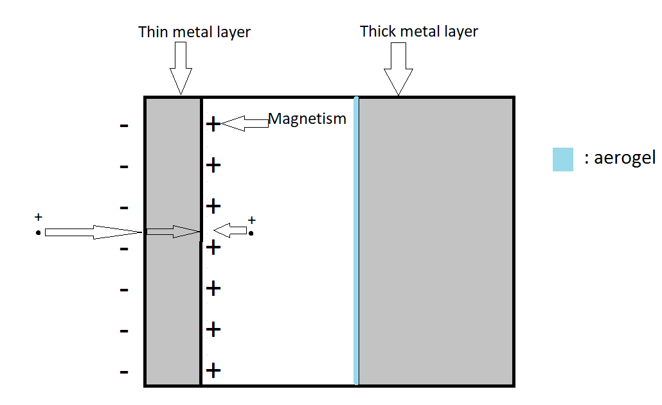

Sketch of the Membrane of the Ship in a Sagittal Cut

We also plan to place a similar system in the door’s hydraulics, in a way that avoids damaging its interior as well as removing dust, by being magnetically attracted to an area where it would not affect the mechanism. In addition, it would be protected by a plastic cover that resists the Moon dust, preventing it from entering. This could also be used on Earth, protecting against corrosive substances.

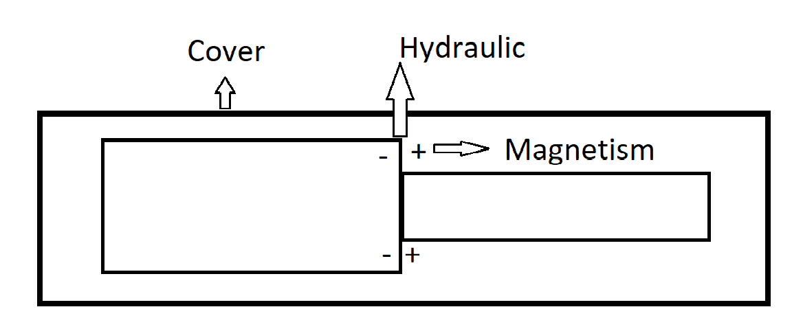

Applications for the Protection of the Astronaut in the Suit

We have created for the astronauts a jumpsuit made of titanium aerogel to create a resistant fiber, with pores smaller than the lunar dust particles. In case of crossing the suit’s Kevlar, this does not damage the astronaut’s body. For the eyes, graphene, since it is very resistant, moldable and transparent. Also, if a dust particle were to enter, crossing the Kevlar, it would be detected by a system of waves of light that would identify the particles within the atmosphere of the suit, reflecting with white materials. Thus knowing the wavelength of the air particles and the various materials inside the suit, if they were to be inside it, they would be differentiated from the dust. This system would inform the astronaut so that he would be able to take them out with the help of the lunar module filter, a system similar to the one used to detect what stars and distant planets are composed of. Plus, it would aso have a computer system to capture them and send them to the astronaut, who would be able to see the information with a computer placed in a comfortable part of his body. This suit could also be used in events where there is a lot of dust to protect human life, such as on the Earth in sandstorms, strong winds, safety against blows in general and, in future missions to Mars, or planets with a lot of dust in the atmosphere, that could endanger the astronaut’s life.

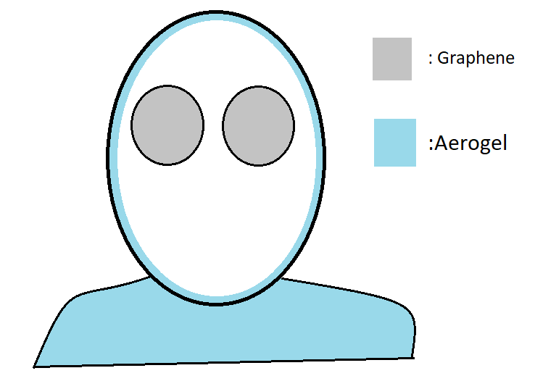

Sketch of the suit of Aerogel and Graphene

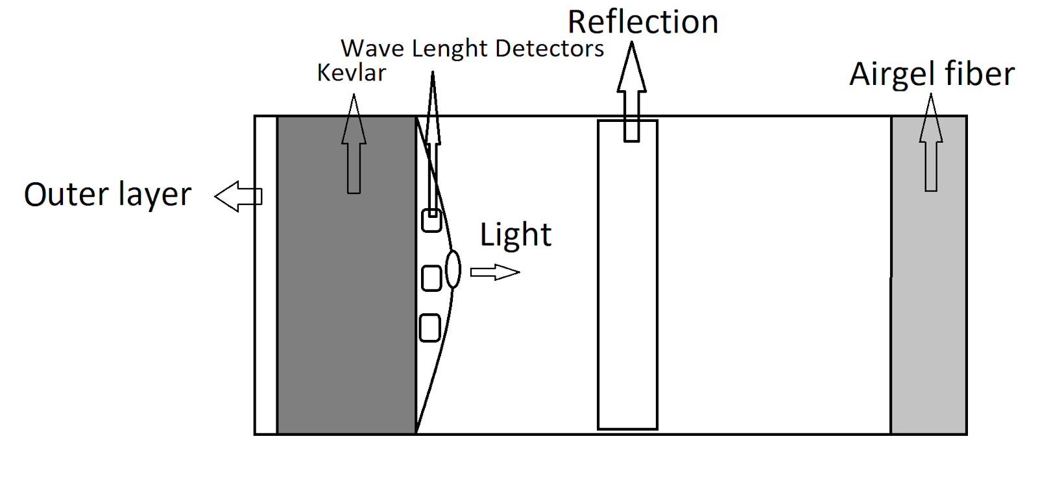

Hydraulics sketch

Lunar Module Filter

We plan to create a small chamber, the same size as the suit (to enable the astronaut to enter it completely) that would work as a cleaning system. This way, the dust particles would be sucked in there, filtered with nanotubes. It would include a program that uses the same wave system of lights to detect the dust’s position, then shoots in those areas with great pressure so that it the dust is aspirated until there is minimal or no presence of it. This would enable the astronaut to enter the spaceship as clean as possible.

In addition, it would also be useful to avoid contaminating the spaceship when the astronauts leave it. It could also be helpful on Earth to remove dangerous substances from the body and in the future for Mars, since Martian dust has similar characteristics to moon dust.

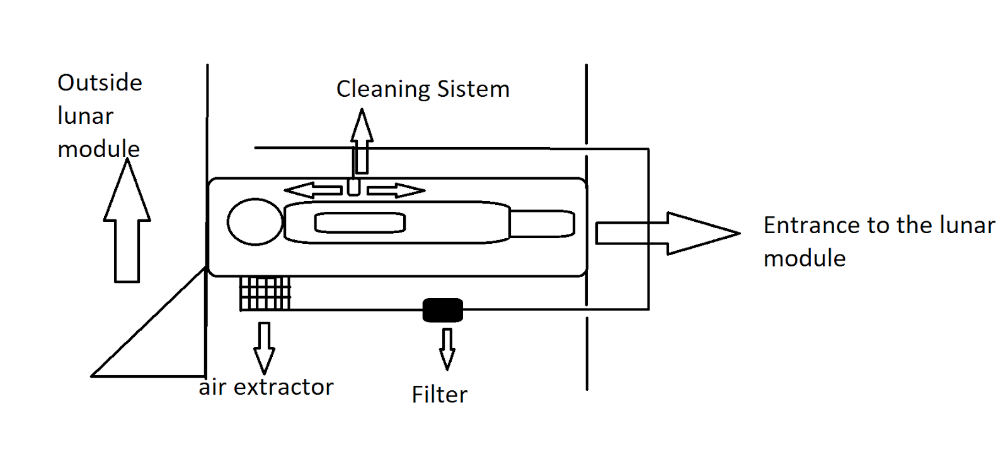

Lunar Module Filter Sketch